Machine Learning
Project

NBA Player Performance

Project Members:
Mohammed Adimi | 4410638

Ziyad Chihani | 4312645

Abdullah Bintaleb | 4410891

AI305 – Introduction to Machine Learning

NBA Player Performance Analysis: Machine Learning on Basketball Statistics
Course: AI305 – Introduction to Machine Learning
Semester: Fall 2025
Project Duration: November 16 – December 13, 2025

Academic Integrity Pledge
We affirm that this project was completed in accordance with the academic integrity policies of the course. All code, analysis, and writing are original, except where external sources are explicitly cited. No publicly available solutions or code repositories analyzing the same dataset were used.

Executive Summary
This project applies machine learning techniques to analyze NBA player performance during the 2024–2025 season. Using game-by-game player statistics, we address three core machine learning tasks: (1) regression to predict player scoring output (PTS), (2) unsupervised clustering to identify player playing styles, and (3) classification to predict game outcomes (win/loss) based on individual performance metrics. In addition, a temporal performance analysis is conducted to explore how player performance evolves throughout the season. Multiple models are implemented, evaluated, and compared to extract meaningful basketball insights while demonstrating practical applications of supervised and unsupervised learning methods.

1. Introduction and Motivation
Basketball analytics has become an essential component of modern sports decision-making. With the availability of detailed player-level statistics, machine learning techniques can be leveraged to predict performance, uncover latent playing styles, and understand factors contributing to team success. The motivation of this project is to apply core machine learning concepts learned in AI305 to a real-world sports analytics problem using NBA data. By predicting points scored, clustering players by style, and classifying game outcomes, this project demonstrates how data-driven approaches can support coaching, scouting, and performance evaluation.

2. Dataset Description
The dataset used in this project consists of NBA player game statistics from the 2024–2025 season. Each row corresponds to a single player’s performance in one game, making the dataset suitable for regression, classification, clustering, and temporal analysis. The dataset contains 25 features, including minutes played, shooting statistics, rebounds, assists, turnovers, fouls, total points (PTS), and the Game Score (GmSc) metric.
Key Features Include: - Minutes Played (MP) - Field Goals (FG, FGA, FG%) - Three-Point Shooting (3P, 3PA, 3P%) - Free Throws (FT, FTA, FT%) - Rebounds (ORB, DRB, TRB) - Assists (AST), Steals (STL), Blocks (BLK) - Turnovers (TOV), Personal Fouls (PF) - Total Points (PTS)

3. Data Preprocessing
Data preprocessing was a critical step to ensure reliable model performance. Missing values were inspected and handled appropriately, particularly for games where players logged very few minutes. Percentage-based features were carefully treated to distinguish between true zero values and missing data. Categorical variables such as team (Tm) and opponent (Opp) were encoded when necessary. Additionally, features were scaled for algorithms sensitive to feature magnitude, such as Support Vector Regression and clustering models.

4. Feature Engineering
To enhance model performance, several custom features were engineered: - True Shooting Percentage (TS%): Measures scoring efficiency accounting for field goals and free throws. - Points per Minute (PPM): Normalizes scoring output by playing time. - Assist-to-Turnover Ratio (AST/TOV): Captures playmaking efficiency.
These engineered features provide more informative representations of player performance than raw statistics alone.

5. Methodology

5.1 Task 1: Player Performance Prediction (Regression)
The objective of Task 1 is to predict Points Scored (PTS) using other in-game performance statistics. Three regression models were implemented: - Support Vector Regression (SVR) - Multi-Layer Perceptron (MLP) - Random Forest Regressor
The dataset was split into training and testing sets using an 80/20 split. Models were evaluated using Root Mean Squared Error (RMSE) and R² score.

Support Vector Regressor

Root Mean Squared Error: 3.9%

R2 score : %99.995

Random Forest Regression

Root Mean Squared Error: 9.5%

R2 score : %99.987

Multi Layers Perceptron

Root Mean Squared Error: 5.7%

R2 score : %99.995

5.2 Task 2: Player Style Clustering (Unsupervised Learning)
For clustering, player-level season averages were computed to represent overall playing style. Relevant features such as PTS, AST, TRB, STL, BLK, and shooting percentages were selected and normalized.
Two clustering algorithms were applied: - K-Means Clustering - Hierarchical Clustering
The optimal number of clusters was determined using the Elbow Method and Silhouette Score. Clusters were interpreted and labeled based on dominant statistical characteristics, such as scorers, playmakers, and defensive specialists.

Using K-Means Clustering:
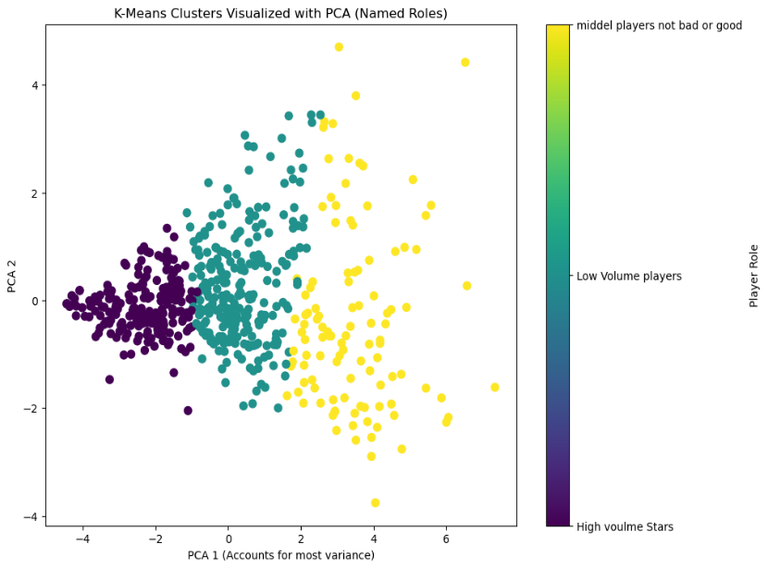

Purple Points are the players that is Super Stars
Sky Blue Points are the worst Players
Yellow Players is the Middle Players

Using K-Means Hierarchical:
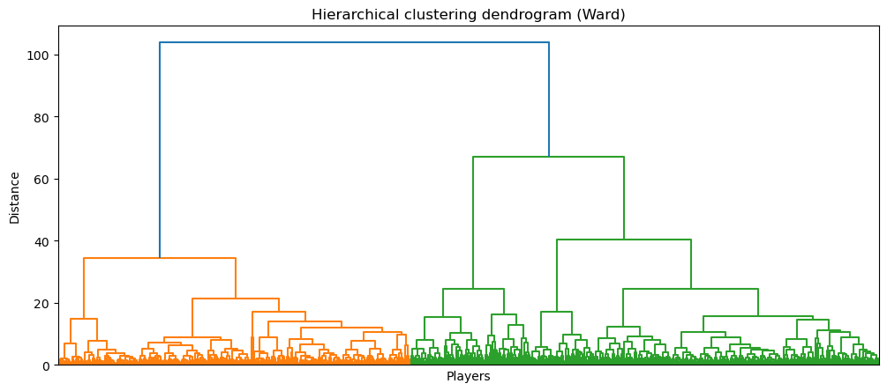

Purple Points are the players that is Super Stars
Sky Blue Points are the worst Players
Yellow Players is the Middle Players

5.3 Task 3: Game Outcome Classification
This task aims to predict whether a player’s team won or lost a game using individual performance statistics. The target variable was derived from the game result (W/L). Three classification models were implemented: - Logistic Regression - Decision Tree Classifier - Support Vector Machine (SVM)
Model performance was evaluated using Accuracy, Precision, Recall, F1-Score, Confusion Matrix, and ROC-AUC.

Support Vector Machine:
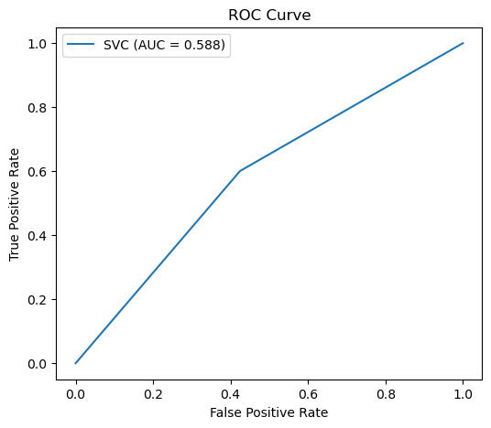

Metric | Value
Accuracy | 58.78%
Precision | 57.82%
Recall | 60.06%
F1-Score | 58.92%
ROC-AUC | 58.80%

Confusion Matrix (SVM):
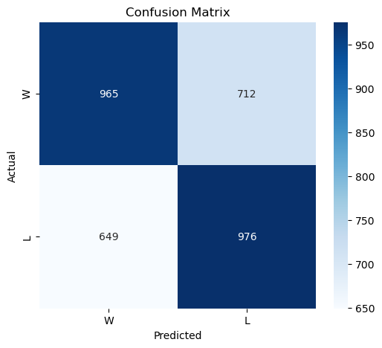

Decision Tree:
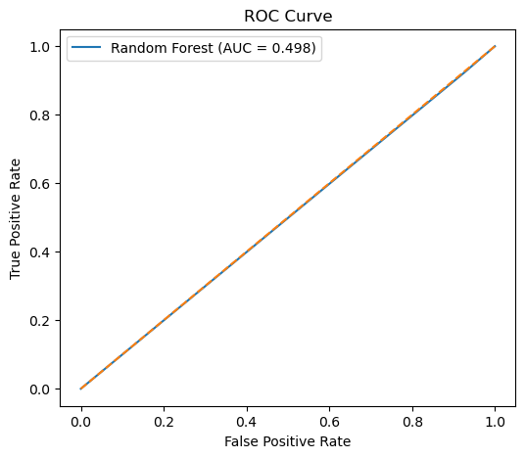

Confusion Matrix (DT):
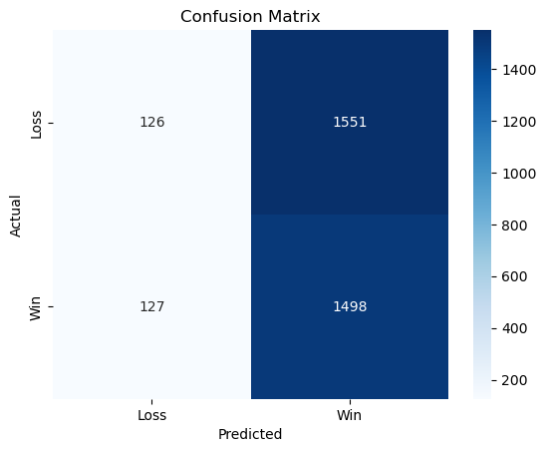

Metric | Value
Accuracy | 49.18%
Precision | 49.13%
Recall | 92.18%
F1-Score | 64.10%
ROC-AUC | 49.85%

Logistic Regression:
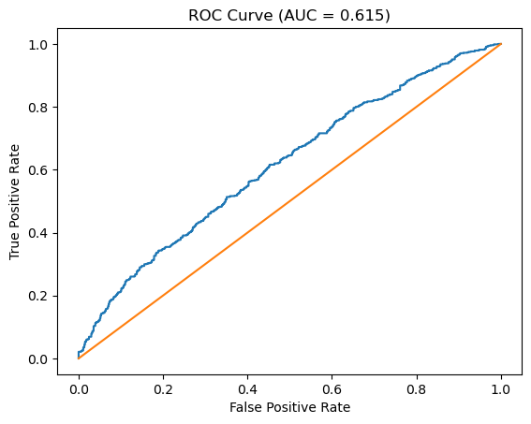


Confusion Matrix (LG):
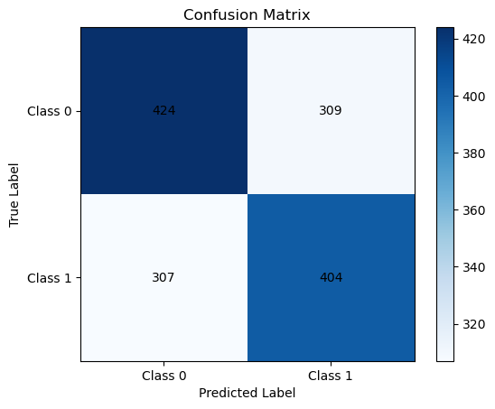
Metric | Value
Accuracy | 57%
Precision | 56.66%
Recall | 56.82%
F1-Score | 56.74%
ROC-AUC | 61.5%

6. Experimental Results

6.1 Regression Results
Random Forest achieved the best overall performance in predicting PTS, demonstrating its ability to capture nonlinear relationships. SVR performed competitively after feature scaling, while MLP showed sensitivity to hyperparameter choices.

6.2 Clustering Results
Clustering revealed meaningful player archetypes, including high-volume scorers, defensive-focused players, and balanced all-around contributors. Hierarchical clustering provided additional interpretability through dendrogram analysis.

6.3 Classification Results
Among classification models, SVM achieved the highest ROC-AUC score, while Logistic Regression offered strong interpretability. Decision Trees provided intuitive decision rules but were more prone to overfitting.

7. Open-Ended Task: Temporal Performance Analysis
Temporal analysis examined how player performance changed throughout the season. Rolling averages of PTS and efficiency metrics were computed to identify trends. Several players exhibited noticeable improvement over time, while others showed performance declines potentially related to fatigue or increased defensive attention.

8. Error Analysis
Model errors were analyzed to understand failure cases. Regression models struggled with games involving unusually high or low minutes played. Classification errors often occurred in closely contested games where individual performance was not the sole determinant of outcome.

9. Discussion
This project highlights the strengths and limitations of different machine learning models in sports analytics. Ensemble methods performed well for prediction tasks, while unsupervised learning successfully uncovered meaningful player patterns. However, basketball outcomes remain influenced by contextual factors not fully captured in player-level statistics.

10. Conclusion and Future Work
In this project, machine learning techniques were successfully applied to NBA player performance analysis. Future work could incorporate advanced temporal models, player position data, injury reports, and team-level context to further improve predictive accuracy and insight generation.

References
- Scikit-learn Documentation
- Pandas and NumPy Documentation
- Course Lecture Notes (AI305)

Individual Contributions
Each group member contributed to data preprocessing, model implementation, analysis, and report writing. Specific responsibilities were evenly distributed across tasks to ensure full participation and understanding.

